# 20 Year History

# 1997: Krkal 1.0

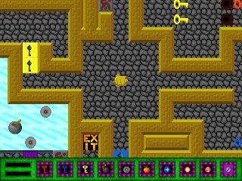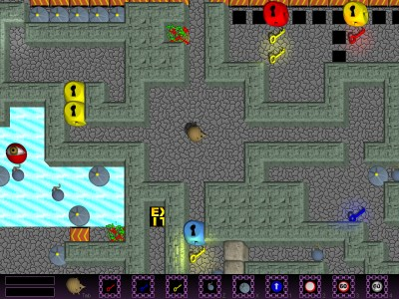Krkal 1 is generally a successful puzzle action DOS game. It is easy to play, you just have to walk through a maze, solve obstacles and get to the exit. It is these obstacles (game objects) that the game is based upon - they are various, their volume is large and they mutually complement each other. In Krkal you'll for example find traditional keys and locks, conveyor belts, ice, explosives, monsters, switches, mirror aimed lasers, magnets and much, much more. Thanks to this the game can offer highly various levels. Today the game can only be played under DOSBox.

1997

2004, 2017

# 2004: Krkal 2.4

Krkal 2.4 was created as a project at the MFF-UK. In addition to the traditional game, which is similar to the original (some of the game objects we transferred, some we didn't and some are brand new), we added an entire environment for game creation. We created a scripting language, script editor, compiler, level editor, graphics engine,... simply everything you need to create games similar to Krkal. Feedbacks were not as good as with version 1.0. The game is playable just as well as the original, but does contain one designer flaw, so players do not stick with it and do not have the patience for harder levels. And the game creator system was a big success, but since not everything works as it should, then it is unusable in praxis.

# 2007 - 2009: Krkal 3.0

This version was created as a diploma thesis at the MFF-UK. I am essentially trying to remove the flaws from version 2.4. I completely rewrote the entire scripting language and wrote a new compiler. Krkal is now formed by replaceable modules, which means far more general usability. Work stopped in 2009. Components relative to the language and the compiler are finished. Thanks to the modularity, they could be well used in another game engine. Unfortunately, this is not enough to revive Krkal (or other games) in version 3.0.

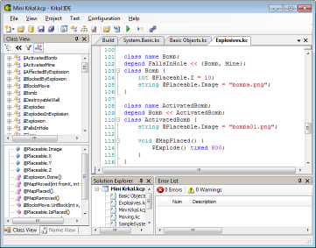

# 2017: Krkal 2.5 - 20th anniversary edition

This is an effort to bring the game to a successful finish. We have level unlocking, a story, new levels and dozens of details merged into a functional whole. Version 2.5 is not pretending to be a game engine, but a complete functional game, or better yet, a remastered edition of the classics from 1997 and 2004.

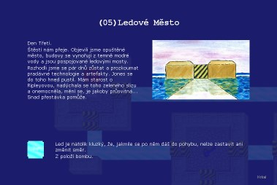

# Why all this?

Basically, it is to simplify game development. When we were working on version 1.0, we worked really hard, because for one we did not have programmer experience, and number two to compile a system made up of about 50 different game objects, which interact together, is no simple task. The outcome was quite a confusing code, where if you want to find errors it will take you a while, and one that is very hard to expand.

For 2.0 we designed a special object oriented language, which is able to easily describe simulation of various, interacting game objects and one that allows easy expandability. These are probably the greatest benefits of the Krkal system. Anytime you have a game with multiple objects, which are somehow living and mutually influencing one another, you furthermore have a multitude of general and special rules and you know that new objects and rules are on their way, then Krkal is the clear choice.

In some way Krkal resembles Game Maker. Here we also have levels and game objects, which are governed by events, objects are linked to graphics and can be placed into the level. The difference is that the GM is intended for starting developers that create rather simpler games. Krkal on the other hand simplifies the development of complex games. (Instead of clicking we have programing in a strong object oriented language).

3.0 focuses on cleaning up the script language, removing errors, security, and modularity. I would compare the changes to a transition from C to C#. I did benefit from my many years of experience and I am proud of the script language and the entire programing environment around it.

We are now coming up on 20 years of creating the first Krkal. And maybe we can come out of hibernation during this 20 year anniversary and actually complete some of our things. Engine 3.0 will not be the case as that would be too demanding. However, it can be the game Krkal itself.

# Version 2.5

Version 2.5 is in the project phase since 2004. Back then we already tried to implement the unlocking of levels. So what's left to do? For example, allow Krkal to run on modern computers and Windows, to restart website, to again understand the old and complex code, to make a good language localization and to tie many loose ends.

And we finally have a story to go with the game. I never thought that a story can be written for Krkal, over the years all efforts we rejected; nothing fit Krkal well, until now.

Let's keep our fingers crossed for version 2.5 so that it can get to people who are truly interested in the game, allow a fan base community to get established, and let's see new levels come to life!

20 years!

D:\My Progs\Krkal 1.0\Bin\Manual\pic\khemr.gif